電通二乙微處理器實驗 實驗結報

實驗名稱 | 四合一七段顯示器
組別 | 32 | 組員 | 楊士緯

- 實驗目的
了解七段顯示器之顯示原理
- 實驗步驟
四合一七段顯示器每隔0.3秒跳一個數字 '從0000->0059->0100->2359
於pin10接一按鍵，按下後歸零
於pin11接一按鍵，按下後倒數計時
- 程式碼
1.
void setup() {
byte numDigits = 4;
byte digitPins[] = {2, 3, 4, 5};
byte segmentPins[] = {8,9,10,11,12,13,14,15};
bool resistorsOnSegments = false; // 'false' means resistors are on digit pins
byte hardwareConfig = COMMON_CATHODE; // See README.md for options
sevseg.begin(hardwareConfig, numDigits, digitPins, segmentPins, resistorsOnSegments);
sevseg.setBrightness(90);
}

void loop()
{
static unsigned long timer = millis();
static int deciSeconds = 0;
sevseg.setNumber(deciSeconds, 0);
if (millis() - timer >= 300)
{
timer += 300;
deciSeconds++;
if (deciSeconds%100 == 59)
{
deciSeconds=deciSeconds+41;
}
else
{
deciSeconds=deciSeconds+1;
}
if (deciSeconds == 2400)
deciSeconds =0 ;
}
sevseg.refreshDisplay(); // Must run repeatedly
}

2.
#include "SevSeg.h"
SevSeg sevseg; //Instantiate a seven segment controller object

void setup() {
byte numDigits = 4;
byte digitPins[] = {2, 3, 4, 5};
byte segmentPins[] = {8,9,10,11,12,13,14,15};
bool resistorsOnSegments = false; // 'false' means resistors are on digit pins
byte hardwareConfig = COMMON_CATHODE; // See README.md for options
sevseg.begin(hardwareConfig, numDigits, digitPins, segmentPins, resistorsOnSegments);
sevseg.setBrightness(90);
pinMode(6,INPUT);
}

void loop()
{
static unsigned long timer = millis();
static int deciSeconds = 0;
boolean val=digitalRead(6);
if(val)
{
sevseg.setNumber(0000, 0);
sevseg.refreshDisplay();
deciSeconds=0;
}
else
{
sevseg.setNumber(deciSeconds, 0);
if (millis() - timer >= 300)
{
timer += 300;
deciSeconds++;
if (deciSeconds%100 == 59)
{
deciSeconds=deciSeconds+41;
}
else
{
deciSeconds=deciSeconds+1;
}
if (deciSeconds == 2400)
deciSeconds =0 ;
}

sevseg.refreshDisplay(); // Must run repeatedly
}
}

3.
#include "SevSeg.h"
SevSeg sevseg; //Instantiate a seven segment controller object

void setup() {
byte numDigits = 4;
byte digitPins[] = {2, 3, 4, 5};
byte segmentPins[] = {8,9,10,11,12,13,14,15};
bool resistorsOnSegments = false; // 'false' means resistors are on digit pins
byte hardwareConfig = COMMON_CATHODE; // See README.md for options
sevseg.begin(hardwareConfig, numDigits, digitPins, segmentPins, resistorsOnSegments);
sevseg.setBrightness(90);
pinMode(6,INPUT);
pinMode(17,INPUT);
}

void loop()
{

static unsigned long timer = millis();
static int deciSeconds = 0;
boolean val=digitalRead(6);
boolean Pin17=digitalRead(17);
if(val)
{
sevseg.setNumber(0000, 0);
sevseg.refreshDisplay();
if(Pin17==HIGH)
deciSeconds=2400;
else
deciSeconds=0;

}
else if(Pin17==HIGH)
{
sevseg.setNumber(deciSeconds, 0);
if (millis() - timer >= 300)

{
timer += 300;
/*deciSeconds--; */
if (deciSeconds%100 == 0)
{
deciSeconds=deciSeconds-41;
}

else
{
deciSeconds=deciSeconds-1;
}
}
if (deciSeconds == 0)
deciSeconds =2400 ;

sevseg.refreshDisplay(); // Must run repeatedly
}
else
{
sevseg.setNumber(deciSeconds, 0);
if (millis() - timer >= 300)
{
timer += 300;
/*deciSeconds++; */
if (deciSeconds%100 == 59)
{
deciSeconds=deciSeconds+41;
}
else
{
deciSeconds=deciSeconds+1;
}
if (deciSeconds == 2400)
deciSeconds =0 ;
}

sevseg.refreshDisplay(); // Must run repeatedly
}
}

- 實驗結果及分析

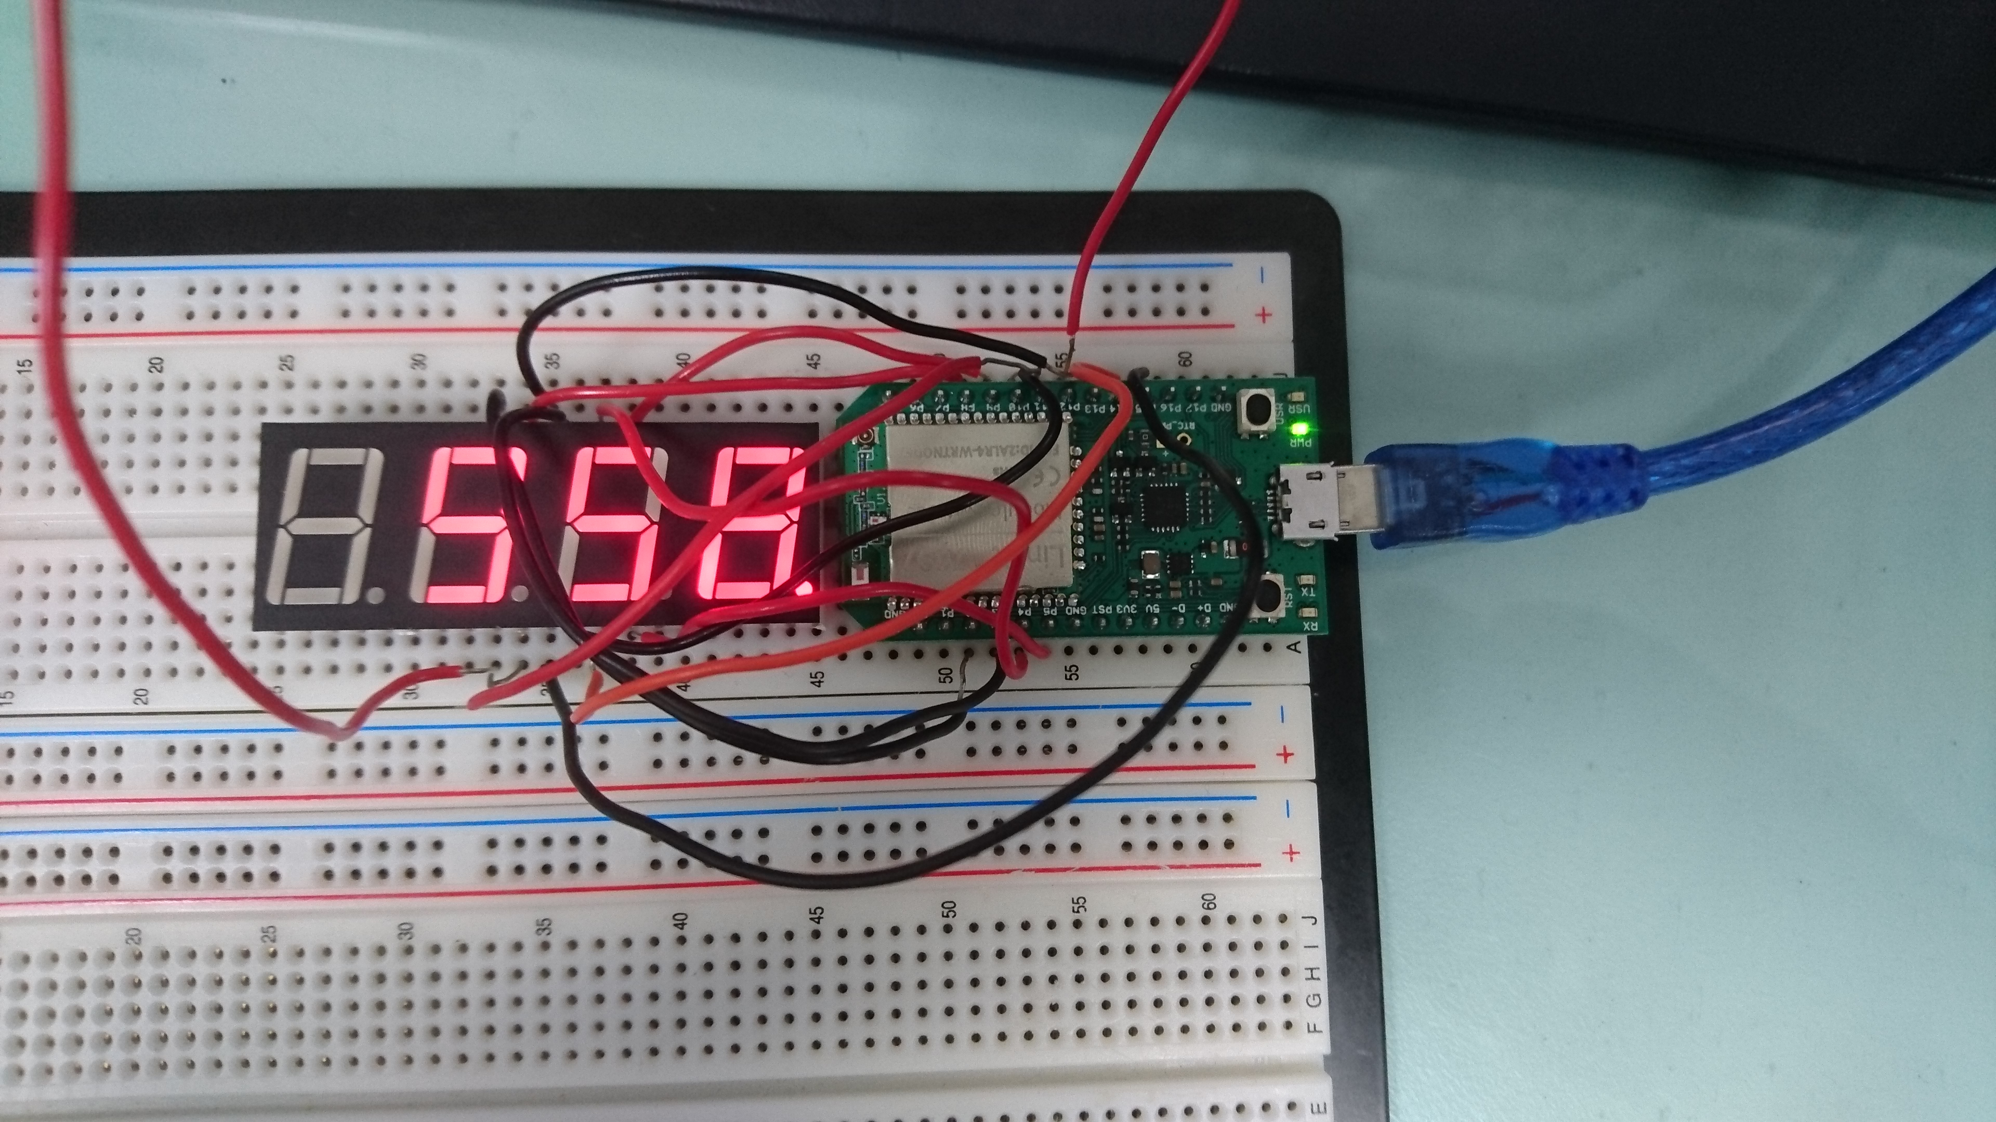
- 心得討論
這次的實驗有點困難，許多組都沒辦法馬上做完，包括我們也是，需要再加強一些才行!

